**Report Development using Azure with POWER BI Tool**

Power BI and Power Query can connect to files such as Excel, CSV, text files and on-premises databases such as SQL Server, Oracle, MySQL. Power BI can connect to many data sources on cloud such as Azure SQL Database, Azure SQL Data Warehouse and etc. Here explaining how to connect from Power BI Desktop to Azure SQL Database. There is also a way of connecting to Azure SQL Database with a direct connection from Power BI

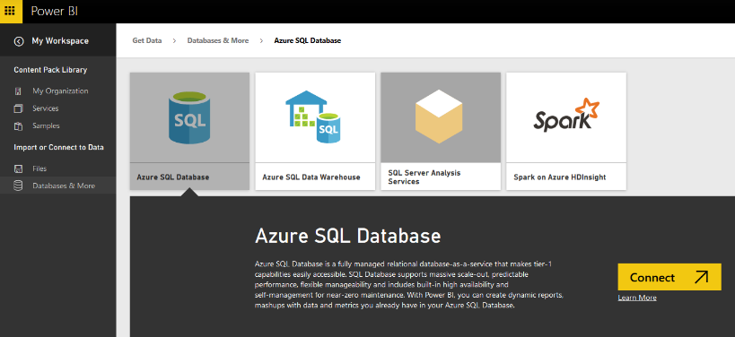

After setting up your Azure Account, go to Azure Portal.  I have to mention here that there are two versions of management portal for Azure. the new Azure portal which is tablet friendly, with newer and better look and feel, and the old management portal. screenshots and steps described in this example all has been done in the new Azure Portal. You can go to Azure portal by using this URL: [https://portal.azure.com](https://portal.azure.com/)

[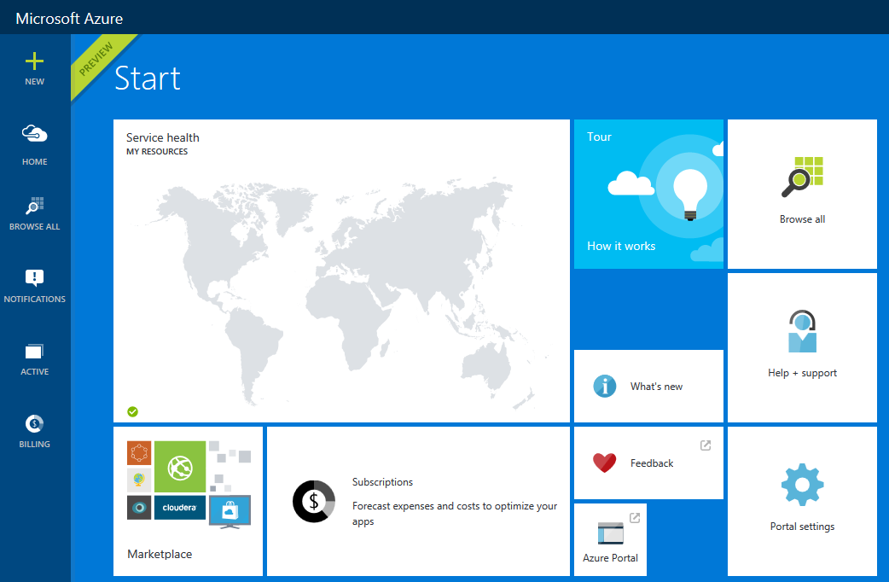](https://radacad.com/wp-content/uploads/2015/09/213.png)

You can manage your Azure services in the management portal by creating new services, editing existing services. Talking about Azure services is out of scope for this example and you need to read books on that topic. However for this example let’s smoothly continue steps to create an Azure SQL Database. Click on New on the top left side and then  under Data + Storage choose SQL Database

[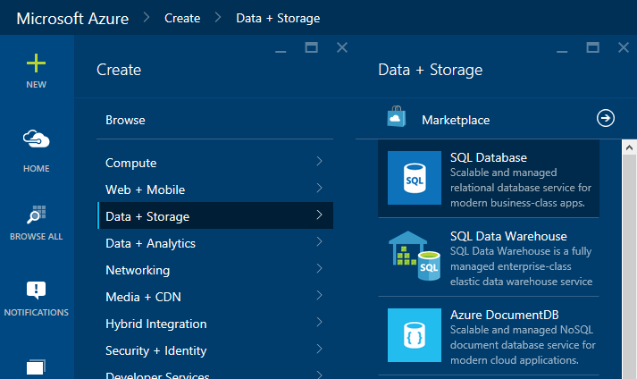](https://radacad.com/wp-content/uploads/2015/09/312.png)

In the SQL Database Create pane, name the database as AdventureWorks LT. You have to choose the server also. Server is like a SQL Server instance that this database will be hosted on that. You can choose from an existing server or you can create a new Server.

[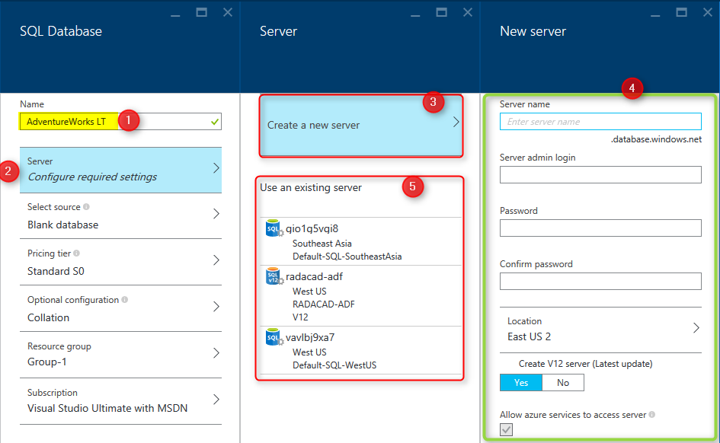](https://radacad.com/wp-content/uploads/2015/09/43.png)

As you can see in screenshot above, after going to Configure required Settings for the Server, you can choose to create new server (numbered 3), which will redirect you to a new pane for setting up the server (numbered 4). or you can choose an existing server (numbered 5).

After setting up the server, you have to select source for the database. for this example choose Sample. after choosing sample you will see the Select Sample option below appears.

[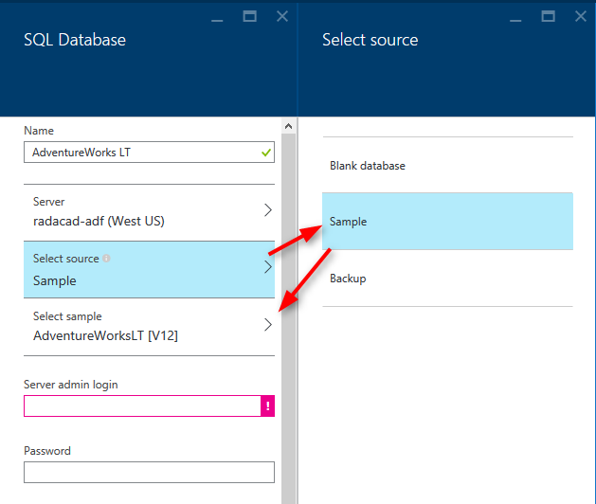](https://radacad.com/wp-content/uploads/2015/09/53.png)

Choose the sample as AdventureWorksLT [V12], and then type in the sever admin login and password (you have defined that when you set up the Server)

[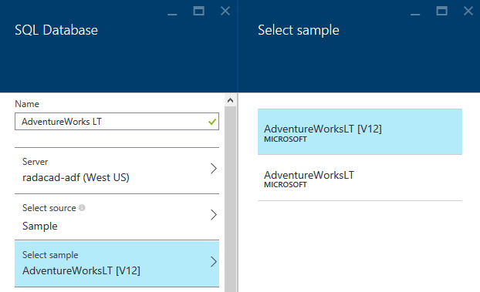](https://radacad.com/wp-content/uploads/2015/09/63.png)

You have to also choose a pricing tier, and resource group. for pricing tier just use one of the tiers (you can better choose yourself), and then for the resource group you can choose an existing one of create a new. A resource group is a grouping for Azure services, you can have a resource group and add all related azure services under that. for example you can have a resource group for Power BI Online Book and create all examples of this book under that. Please note that the resource group name should not have spaces in the name, but it can have dashes.

[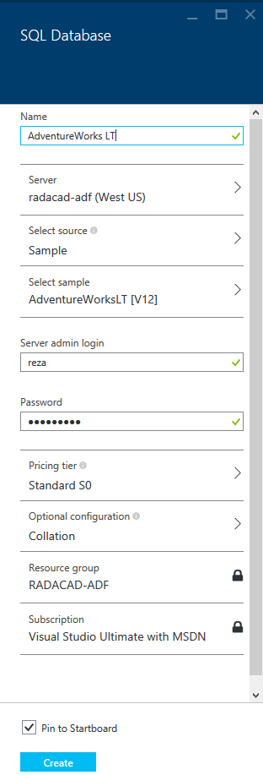](https://radacad.com/wp-content/uploads/2015/09/73.png)

After all the configuration click on Create so the SQL DB creates. the tick on check box for pin to Startboard will bring the SQL DB on the first welcome page (start board) of the Azure Portal. It may take a bit time for the database to be created. After completion of creating database process, you will be redirected to database page in azure portal (if you didn’t, then click on the AdventureWorks LT database on start board to go to its pane). screenshot below is showing the database created

[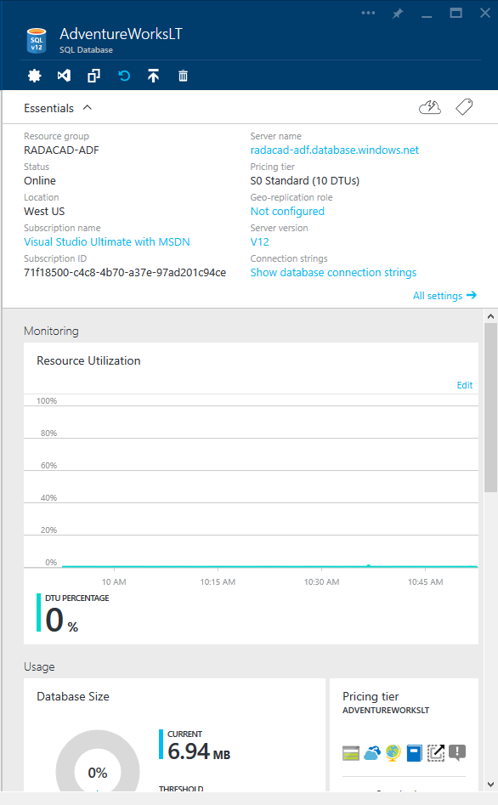](https://radacad.com/wp-content/uploads/2015/09/83.png)

Now you are all set, example database is ready to be used in Power BI.

**Get Data From Azure SQL Database**

You can connect to Azure SQL Database from Power BI Desktop or Power Query for Excel. Both methods works same. Let’s go through the connection from Power BI Desktop. Before starting steps I have to mention that Power BI Desktop connection to Azure SQL Database is an off-line connection. Off-line connection here means the data from Azure SQL Database will be loaded into the Power BI model and then reports will use the data in the model, this disconnected way of connection is what I call off-line. The off-line connection to Azure SQL DB can be scheduled in the Power BI website to be refreshed to populated updated data from the database. In this section we will create the connection from Power BI Desktop to Azure SQL DB, and in the next section following you will learn how to schedule the data refresh.

Open the Power BI Desktop and Get Data from Azure SQL Database

[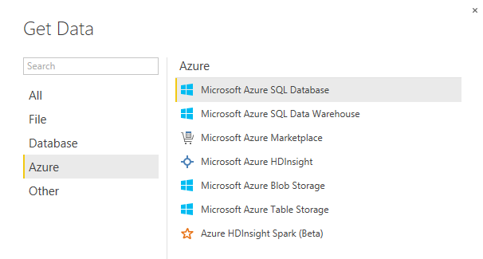](https://radacad.com/wp-content/uploads/2015/09/93.png)

In Power Query for Excel you can also follow the path mentioned in screenshot below

[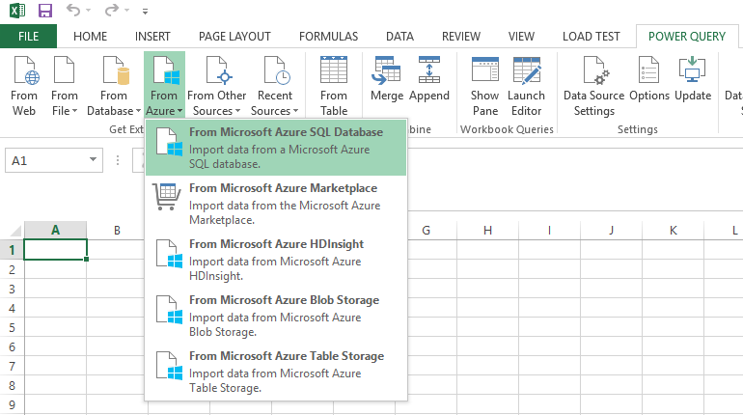](https://radacad.com/wp-content/uploads/2015/09/103.png)

You need to enter the server name in SQL Server Database dialog box. Remember that you’ve set up the server when you created Azure SQL DB. if you don’t know what is the server for your database, simply find it through Azure portal under the Azure SQL DB pane;

[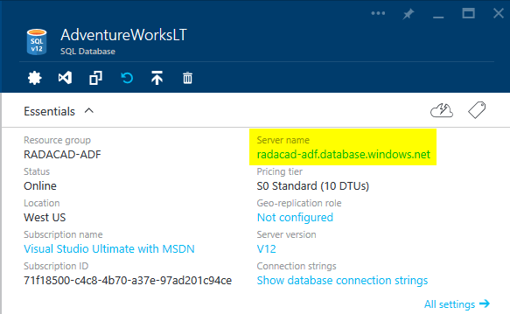](https://radacad.com/wp-content/uploads/2015/09/115.png)

Type in the server name in SQL Server Database dialog box in Power BI Desktop. and type in the database as AdventureWorks LT. leave the SQL statement as is. then press OK

[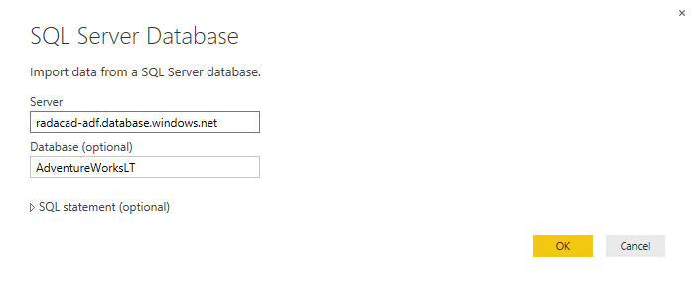](https://radacad.com/wp-content/uploads/2015/09/123.png)

It is very likely that you get to the window that says Unable to Connect. This window is saying that Power BI Desktop cannot connect to Azure SQL DB and the reason is that the Azure SQL Server didn’t allowed your IP address to pass through its firewall. I have to mention that Azure SQL Server by default doesn’t allow external IP addresses to connect to it. if you want to connect to any databases on Azure SQL Server you have to allow the IP of that machine to pass through. This is not your internal network IP, this is the IP that your internet connection has. You can find the IP easily. It is mentioned in Unable to Connect error message below!

[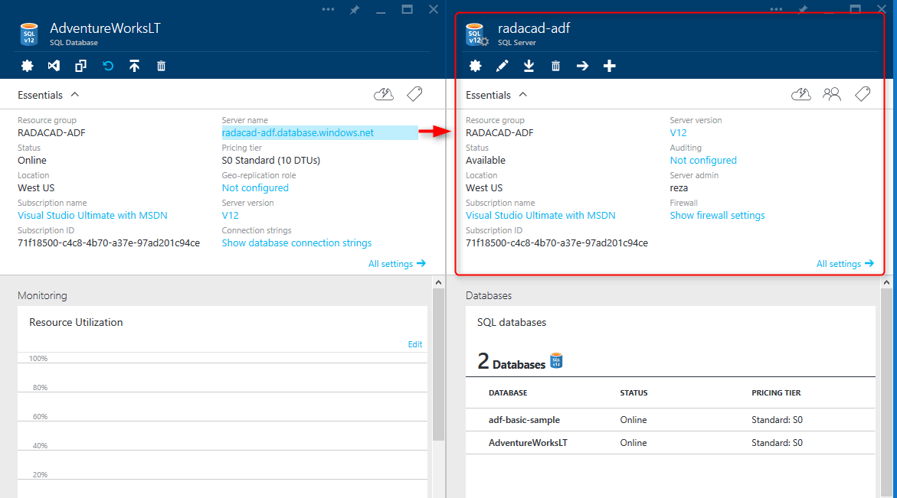](https://radacad.com/wp-content/uploads/2015/09/143.png)

Click on Show firewall settings. In the Firewall Settings pane, enter the new IP as a rule, and then save it.

[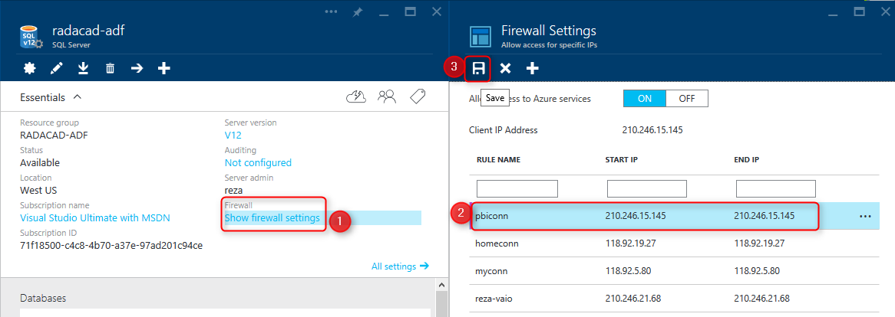](https://radacad.com/wp-content/uploads/2015/09/153.png)

Now you can try again to connect from Power BI Desktop (if you get that error again, just wait for few minutes and try again. Sometimes it takes few minutes for changes to take effect). After a successful connection you should be able to see Navigator dialog box with the structure of AdventureWorksLT database

[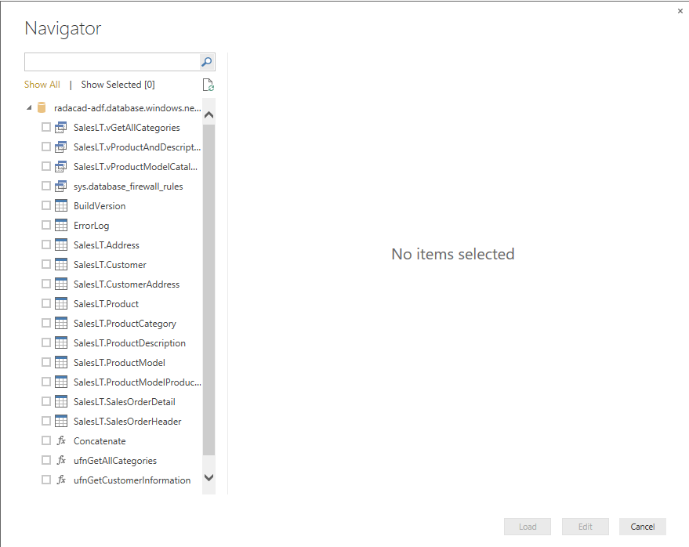](https://radacad.com/wp-content/uploads/2015/09/163.png)

As you can see in the navigator all views, tables and functions will be listed. You can choose multiple objects and then continue editing them in the Edit Queries or Power Query Editor window. For this example I’ve chosen these tables: Customer, Product, ProductCategory, ProductModel, SalesOrderDetail, and SalesOrderHeader.

You can then choose these tables with their fields to be used for building a report without any modification in Power Query or Data tab. You can even see that Power BI and Power Query understand the relationship in Azure SQL Database and load the same relationship in the Power BI model.

[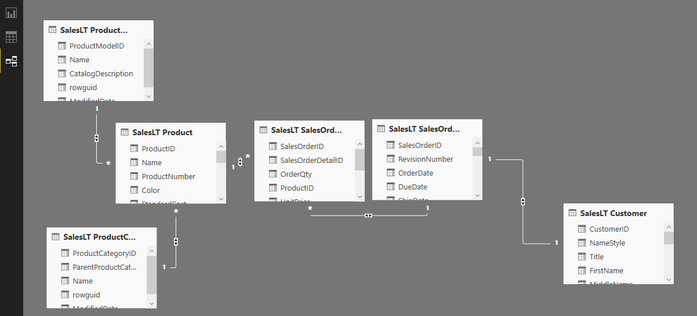](https://radacad.com/wp-content/uploads/2015/09/173.png)

This section is still one of the early chapters of Power BI online book, and I don’t want to discuss visualization and modelling. However for this example I’ve build a simple chart, the chart is a clustered column chart with Color (from Product table) as Axis, and SalesPerson (from Customer) as Legend, and OrderQty (from SalesOderDetail) as Value.

[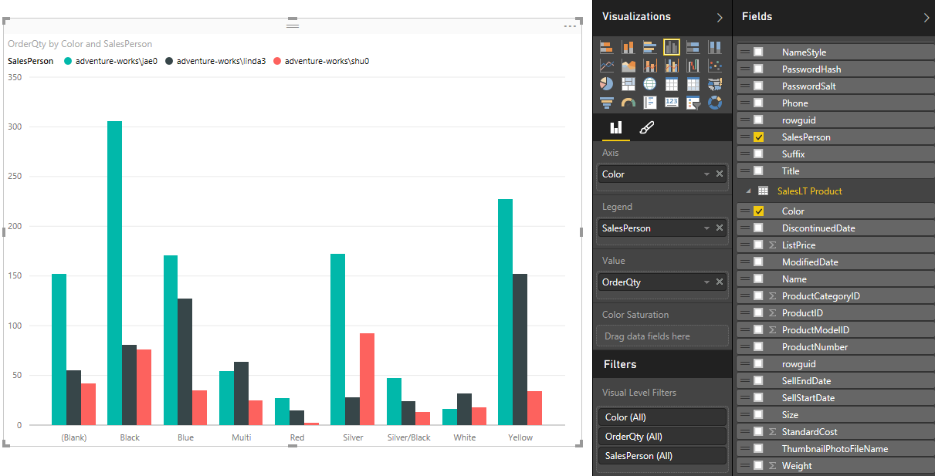](https://radacad.com/wp-content/uploads/2015/09/183.png)

The chart is simple, but still revealing something interesting. Jae0 did the most sales, however color wise each sales person did the best in specific color. shu0 was best at Yellow. lina3 at Silver, and Jae0 at Black. Now you can publish your report into Power BI website with the Publish menu option. after publishing the report you would be able to see that under your Power BI account in the website.

[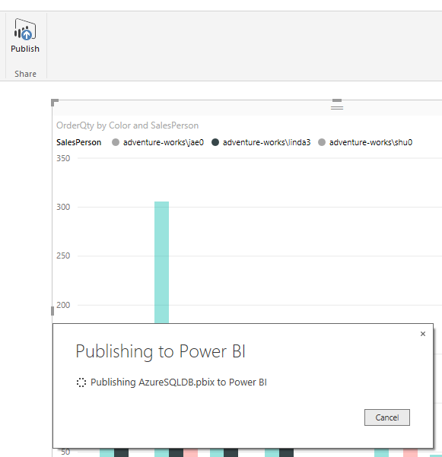](https://radacad.com/wp-content/uploads/2015/09/193.png)